Changing Your Signature in Web Mail

- Click the settings icon (gear) in the top right corner
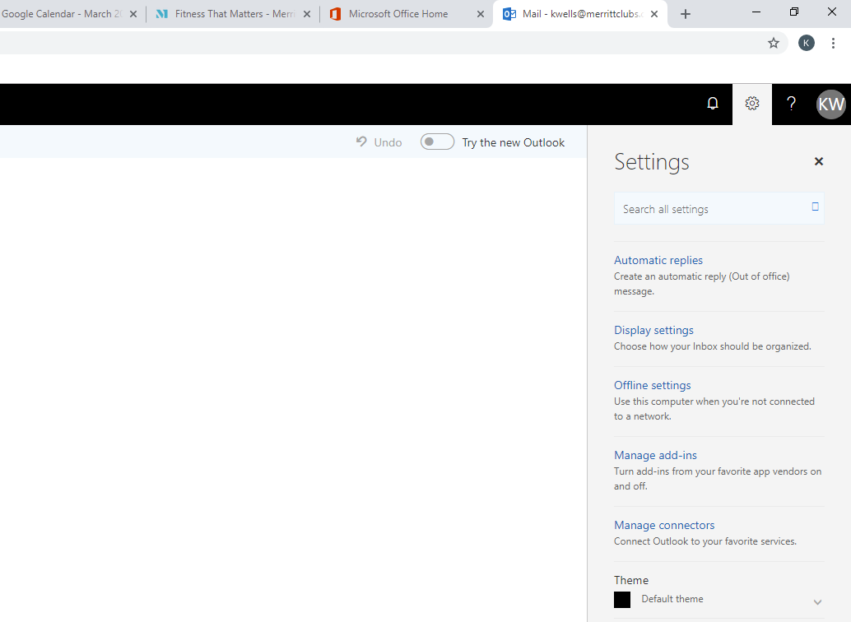

- Type “Email Signature” in the search box; then, click “Email Signature”

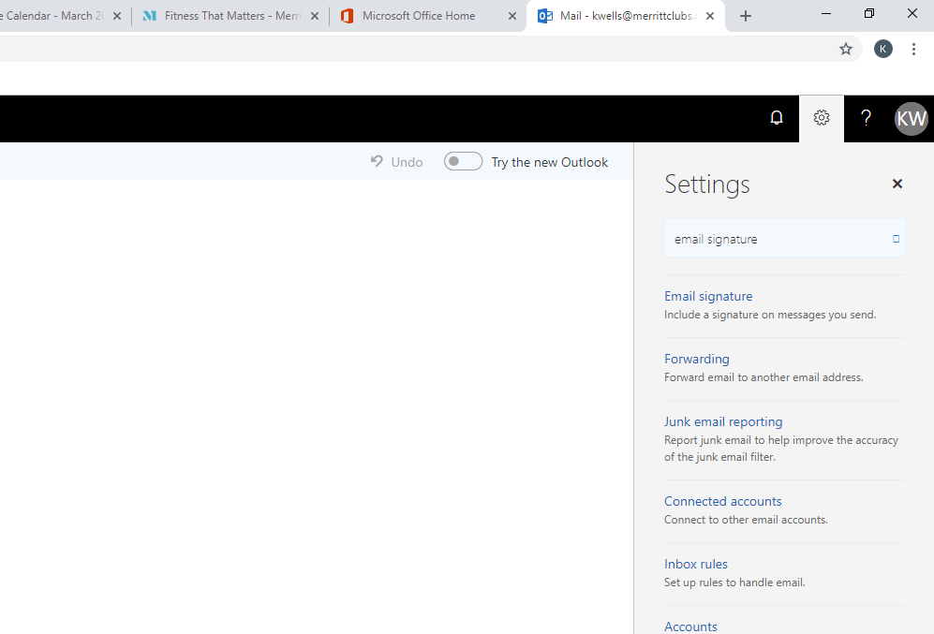

- Copy and paste the sample email signature below. Paste the signature into the box. MAKE SURE TO EDIT THE SAMPLE SIGNATURE AND ADD YOUR NAME, YOUR TITLE, AND YOUR HOME CLUB’S ADDRESS!! Select “automatically include my signature on new messages I compose” & “automatically include my signature on messages I forward or reply to”

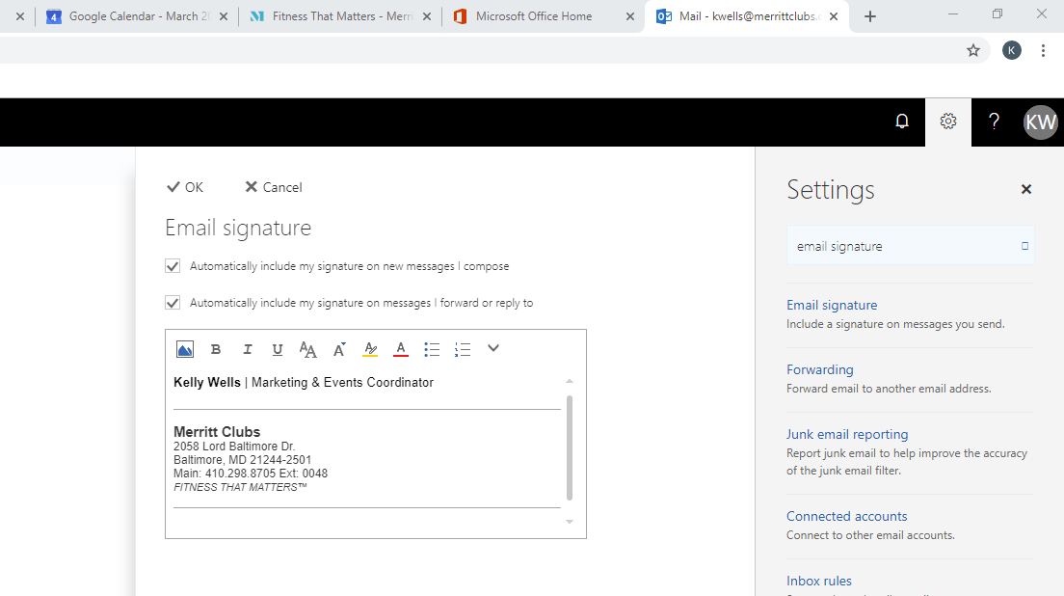

- Click “OK” to save!

Leslie Warren | Graphic Designer

Merritt Clubs – Home Office
2058 Lord Baltimore Dr. | Baltimore, MD 21244-2501
Main: 410.298.8705 Ext: 0039
FITNESS THAT MATTERS™

Changing Your Signature in Outlook
- Click “File” in the top left corner of your screen.
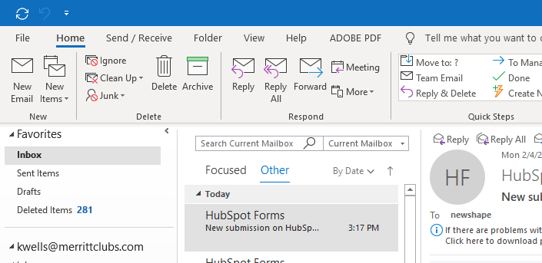
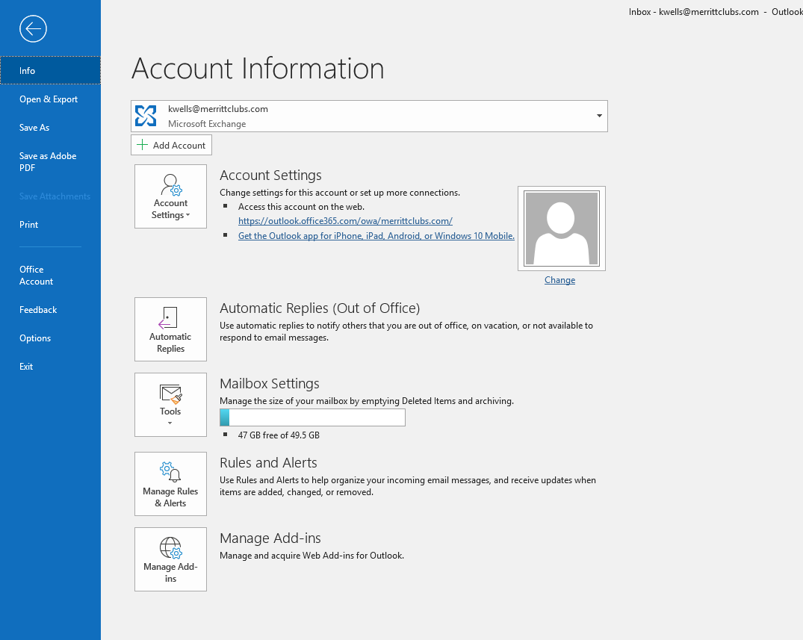

- Click on “Options” in the left-hand column then, click “Mail.” Once here, select “Signatures”
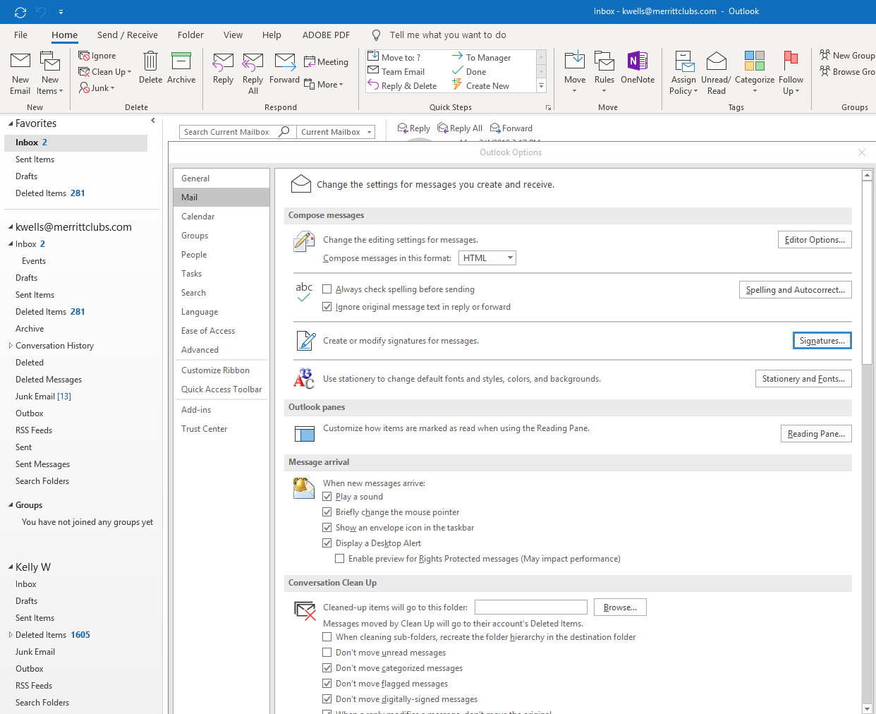
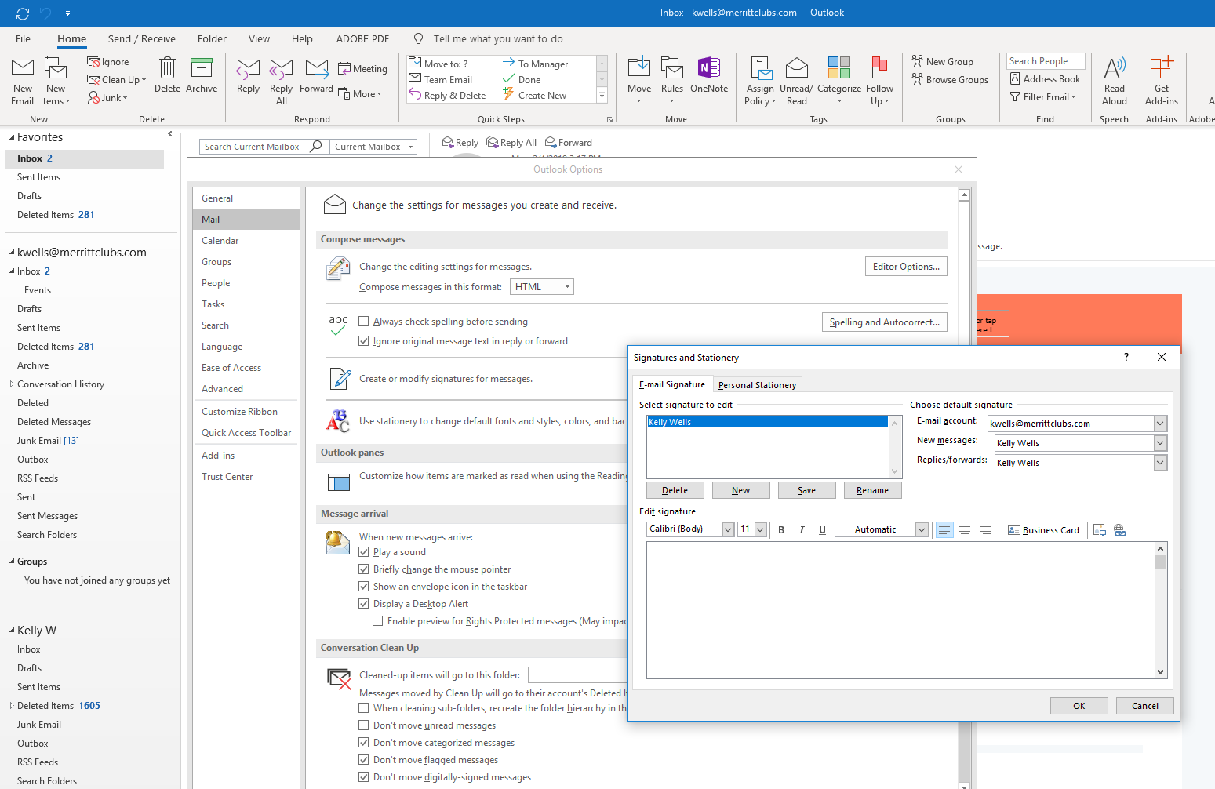

- Copy and paste the sample email signature from the email. Paste the signature into the box. MAKE SURE TO EDIT THE EXAMPLE SIGNATURE AND ADD YOUR NAME, YOUR TITLE, AND YOUR HOME CLUB’S ADDRESS!! Click “Save”
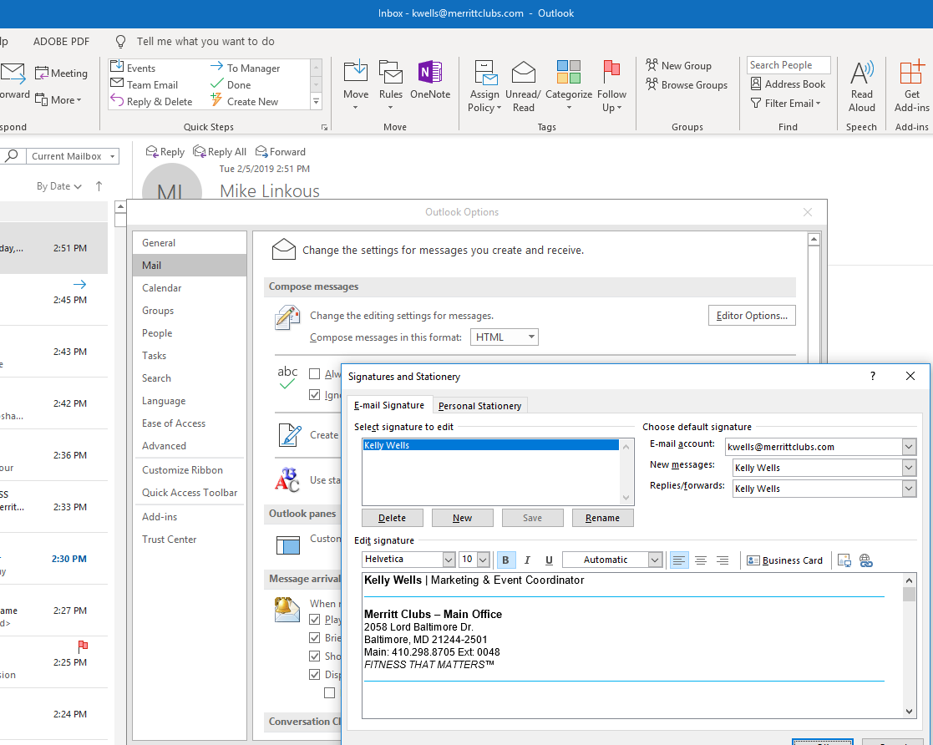

- If the signature doesn’t align together on the left or looks different than these images, you may try copying a signature directly from someone’s email and paste it into your outlook instead of copying it from this document. If you still have problems with your signature, please contact marketing@merrittclubs.com

*Don’t forget to change the outlook settings on all your apps, including your phone if you use it. You may copy and paste this signature, it will get rid of the lines and font formatting on the phone app.

